**Fertilizer Recommendation Calculator**

**Submitted to**

**SPL2 Coordinators**

Institute of Information Technology

University of Dhaka

**Submitted by**

Md. Tahmidur Rahman Khan BSSE0801

Abdullah Al Jubaer BSSE812

5th Semester, BSSE 8th Batch

Institute of Information Technology

University of Dhaka

Submission Date: 20 March 2018

**Letter of Transmittal**

20th March, 2018

Coordinator

Software Project Lab 2

Institute of Information Technology

University of Dhaka

Subject: Submission of software requirement specification document on ‘Fertilizer Recommendation Calculator’.

Sir

We, the team on which the project on ‘Fertilizer Recommendation Calculator’ was assigned, are submitting our software requirement specification document with due respect. We have tried our best for preparing the document. However, it might lack perfection.

So, may we therefore, hope that you would be kind enough to accept our document and oblige thereby.

Sincerely yours

Md. Tahmidur Rahman Khan (BSSE0801)

Abdullah Al Jubaer (BSSE0812)

BSSE 8th Batch

Institute of Information Technology

University of Dhaka

-----------------------------

Date and Signature

Dr. Mohammad Shoyaib

Professor

Institute of Information Technology

University of Dhaka.

**Acknowledgement**

We are highly indebted for getting such a tremendous opportunity to prepare the report on Fertilizer Recommendation Calculator. We would like to thank whole-heartedly our supervisor, Dr. Mohammad Shoyaib, Professor, Institute of Information Technology, University of Dhaka, for giving us guidelines about how we can prepare this report. In completing this report, we have collected various important data and information from Bangladesh Agricultural University (BAU). We are thankful to every faculty member of BAU who provided us with necessary data and information, especially Abdullah Al Mahmud (Ph.D. fellow, Department of Soil Science, BAU).

**Abstract**

This study is made for ‘Fertilizer Recommendation Calculator’. The scope of the study is to analyze how the farmers utilize the land by providing adequate amount of fertilizers and get the best yield of crops and how information regarding the soil is collected by the experts. The study also includes knowing the drawbacks and design the SRS (software requirements and specification) of the system. The object of the study is to develop an SRS of ‘Fertilizer Recommendation Calculator’. This study also describes the how this SRS can be used to better the current system.

**Table of Contents**

Chapter 1 1

Introduction 1

1.1 Purpose 1

1.2 Intended Audience 1

Chapter 2 2

Inception 2

2.1 Introduction 2

2.2 Conclusion 6

Chapter 3 7

Elicitation 7

3.1 Introduction 7

3.2 Eliciting Requirements 7

Chapter 4 17

Scenario Based Modeling 17

4.1 Introduction 17

4.2 Definition of Use Case 17

4.3 Use Case Diagrams 18

4.4 Activity Diagram 32

4.5 Swim-lane Diagram 39

Chapter 5 46

Data Modeling 46

5.1 Data modeling concept 46

5.2 Data objects 46

5.3 Entity Relationship Diagram 54

5.4 Schema Diagram 55

Chapter 6 56

Class Based Modeling 56

6.1 Class Based Modeling Concept 56

6.2 General Classification 56

6.3 Selection Criteria 59

6.4 Associate Noun and Verb Identification 60

6.5 Attribute Selection 62

6.6 Methods Identification 64

6.7 Finalizing Classes 66

6.8 Class Relation Collaboration 67

6.9 Class Diagram 75

Chapter 7 76

Behavioral Modeling 76

7.1 State Transition Diagram 76

7.2 Sequence Diagram 83

Chapter 8 84

Data Flow Diagram 84

Chapter 9 86

Conclusion 86

**Table of Figures**

Figure 1: Use Case Level 0 - Fertilizer Recommendation Calculator 18

Figure 2: Use Case Level 1 - FRC Subsystems 20

Figure 3: Use Case Level 1.1: Authentication 22

Figure 4: Use Case Level 1.2: Required Fertilizer Calculation 25

Figure 5: Use Case Level 1.6 - Soil Sampling 30

Figure 6: Activity Diagram Level 1.1.1: Sign Up 32

Figure 7: Activity Diagram Level 1.1.2: Login and password recovery 33

Figure 8: Activity Diagram Level 1.1.3: Access Permission 34

Figure 9: Activity Diagram Level 1.2 - Required Fertilizer Calculation 35

Figure 10: Activity Diagram Level 1.3 – Nutrients Balance Sheet 36

Figure 11: Activity Diagram Level 1.4.1 – Upload Soil Form 37

Figure 12: Activity Diagram Level 1.4.2 – Query and Update 38

Figure 13: Swim-Lane Level 1.1.1: Sign Up 39

Figure 14: Swim-Lane Level 1.1.2 – Login and Password Recovery 40

Figure 15: Swim-Lane Level 1.1.3: Access Permission 41

Figure 16: Swim-Lane Level 1.2: Required Fertilizer Calculation 42

Figure 17: Swim-Lane Level 1.3: Nutrients Balance Sheet 43

Figure 18: Swim-Lane Level 1.4.1 – Upload Soil Form 44

Figure 19: Swim-Lane Level 1.4.2 – Query and Update 45

Figure 20: Relation between data objects 53

Figure 21: Entity Relationship Diagram 54

Figure 22: CRC Crop 67

Figure 23: CRC Nutrient 68

Figure 24: CRC AEZ 69

Figure 25: CRC Fertilizer 69

Figure 26: CRC Recommendator 70

Figure 27: CRC Input 71

Figure 28: CRC Output 72

Figure 29: CRC Sample 73

Figure 30: CRC User 74

Figure 31: State Transition User 78

Figure 32: State Transition Sample 79

Figure 33: State Transition Recommendation 79

Figure 34: State Transition Output 80

Figure 35: State Transition Nutrient 80

Figure 36: State Transition Input 81

Figure 37: State Transition Fertilizer 81

Figure 38: State Transition Crop 82

Figure 39: State Transition AEZ 82

Figure 40: Data Flow Diagram Level 0 84

Figure 41: Data Flow Diagram Level 1 85

**List of Tables**

Table 1: Noun Identification for Data Modelling 50

Table 2: Final Data Objects 51

Table 3: General Classifications of nouns 58

Table 4: Selection Criteria for potential classes 59

Table 5: Associated nouns and verbs of the potential class 61

Table 6: Attribute selection of classes 63

Table 7: Method Selection of classes 65

Table 8: Event Identification 77

# Chapter 1

## Introduction

This chapter is a part of the software requirement specification for the project ‘Fertilizer Recommendation Calculator’. In this chapter intended audience for the project are focused on.

### 1.1 Purpose

This document briefly describes the Software Requirement Analysis of ‘Fertilizer Recommendation Calculator’. It contains functional, non-functional, and supporting requirements and establishes a requirement baseline for the development of the system. The requirements specified in the SRS are independent, uniquely numbered and organized by topic. The SRS serves as an official mean of communicating user requirements to the developer and provides a common reference point for both the developer team and the stakeholder community. The SRS will evolve over time as users and developers work together to validate, clarify and expand its contents.

### 1.2 Intended Audience

This SRS in intended for several audiences including the customers as well as the project managers, designers, developers and testers.

* The customers will use this SRS to verify that the developer team has created a product that is acceptable to the customers.
* This project managers of the developer team will use this SRS to plan milestones and a delivery date and ensure that the developing team is on track during development of the system.

# Chapter 2

## Inception

In this chapter, the inception part of the SRS will be discussed briefly.

### 2.1 Introduction

Inception is the beginning phase of requirements engineering. It defines how a software project gets started and what the scope and nature of the problem to be solved is. The goal of the inception phase is to identify the concurrent needs and conflicting requirements among the stakeholders of a software project. At project inception, a basic understanding of the effectiveness of preliminary communication and collaboration between the other stakeholders and the software team was established.

To establish the groundwork, the following factors have been worked on to the inception phase:

* List of stakeholders
* Recognizing multiple viewpoints
* Working towards collaboration
* Requirements questionnaire

#### 2.1.1 List of Stakeholders

Stakeholders refer to any person or group who will be affected by the system directly or indirectly. Stakeholders include end-users who interact with the system and everyone else in an organization that might be affected by its installation. At inception, a list of people who will contribute input as requirements are elicited. The initial list will grow as stakeholders are contacted because every stakeholder will be asked: “whom else do you think I should talk to?”

The following stakeholders were identified for the ‘Fertilizer Recommendation Calculation”.

**Normal User**: Normal user is the general software user.

Field Worker: Field workers are responsible for collecting soil samples. They also provide information and suggestion to the farmers about cultivation processes.

**Soil expert**: A soil expert is an individual who analyzes and researches soil. He/she researches the sample and updates the data.

**Admin**: Admin coordinates all the work. He/she decides what task will be given to which individual. He/she is also responsible for hiring and firing of an individual.

**Software Developer**: A software developer is concerned with facets of the software development process, including the research, design, programming, maintenance and testing of computer software. He will be responsible for the outcomes of the software.

#### 2.1.2 Recognizing Multiple Viewpoints

Different stakeholders demand different features from the software. To satisfy the stakeholders, most of these features should be included in the software.

**Normal user’s viewpoint**

* Error free system
* Fast generation of fertilizer output
* Provide accurate cost for the required fertilizers
* Offline result
* User friendly
* Suggestion for best crop pattern for a specific region
* Application for feature phone (normal phone)
* Keep history

**Field Worker’s viewpoint**

* User friendly
* Error free system
* Suggestion for best crop pattern for a specific region
* Fast generation of fertilizer output
* Provide as less input as possible
* Less internet data usage
* Keep history

**Expert’s viewpoint**

* Error free system
* Fast generation of fertilizer output
* Nutrient requirements for a specific crop for a particular region
* User friendly nutrient balance sheet
* Soil sampling
* Keep history

**Admin’s viewpoint**

* Error free system
* Strong authentication
* User friendly

**Developer’s viewpoint**

* Easy to built
* Error free effective software
* No ambiguous requirement
* Getting a decent amount of money for project budget

#### 2.1.3 Working towards collaboration

While working with different stakeholders, some conflicting and common viewpoints can be noticed. For this reason, final requirements can be gotten by collaborating the viewpoints.

**Common viewpoints**

* Error free effective system
* User friendly
* Easy to maintain the software

**Conflicting viewpoints**

* Developing the project in minimum budget
* Less internet usage
* Application for feature phone (normal phone)
* Keep history

**Final Requirements**

* Error free effective system
* User friendly
* Suggestion for best crop pattern for a specific region
* Fast generation of fertilizer output
* Nutrient requirements for a specific crop for a particular region
* User friendly nutrient balance sheet
* Soil sampling
* Offline result

#### 2.1.4 Requirements Questionnaire

At first some context free questions were asked for identifying the stakeholders. Context free questions are helpful to identifying some stakeholders who cannot be identified by structural questions. Then questions regarding the software were regarding to know their demands.

### 2.2 Conclusion

In this inception phase, a basic understanding of the problem was developed and a preliminary nature of the solution was obtained. The requirements which are identified in this phase, will be used later for further steps of requirement engineering.

# Chapter 3

## Elicitation

This chapter specifies the Elicitation phase.

### 3.1 Introduction

Requirements Elicitation is a part of requirements engineering that is the practice of gathering requirements from the users, customers and other stakeholders. Many difficulties were faced, like understanding the problems, making questions for the stakeholders, limited communication with the stakeholders due to a short amount of time and volatility. Though it is not easy to gather requirements within a very short time, these problems have been surpassed in an organized and systematic manner.

### 3.2 Eliciting Requirements

The main task of this phase is to combine the elements of problem solving, elaboration, negotiation and specification. The collaborative working approach of the stakeholders is required to elicit the requirements. The following tasks were done for eliciting requirements-

* Collaborative Requirements Gathering
* Quality Function Deployment
* Usage Scenarios
* Elicitation work products

#### 3.2.1 Collaborative Requirements Gathering

The meetings with the stakeholders created an indecisive state to elicit the requirements. To solve this problem, more than one meeting was held with the stakeholders. A slightly different scenario from these approaches has been found following activities have been completed to accomplish this task.

* The meetings were conducted with the owner, employees and suppliers. They were questioned about their requirements and expectations from the Grocery Management System.
* They were asked about the problems they were facing with the current manual system.
* Lastly final requirement list was selected from the meetings.

#### 3.2.2 Quality Function Deployment

Quality Function Deployment (QFD) is a technique that translates the needs of the customer into technical requirements for software. Ultimately the goal of QFD is to translate subjective quality criteria into objective ones that can be quantified and measured and which can then be used to design and manufacture the product. It is a methodology that concentrates on maximizing customer satisfaction from the software engineering process. The requirements, which are given below, are identified successfully by the QFD.

##### 3.2.2.1 Normal Requirements

The normal requirements are generally the objectives and goals that are stated for a product or system during meetings with the customer. The presence of these requirements fulfills customers’ satisfaction. These are the normal requirements for the project.

* Suggestion for best crop pattern for a specific region
* Fast generation of fertilizer output
* Nutrient requirements for a specific crop for a particular region
* User friendly nutrient balance sheet
* Soil sampling
* Offline result

##### 3.2.2.2 Expected Requirements

These requirements are intrinsic to the product or system and may be so elementary that the customer does not explicitly state them. Their absence will be a cause for significant dissatisfaction. Below the expected requirements for our project are briefly described.

* Error free software
* User friendly
* Effective system
* No ambiguous feature

##### 3.2.2.3 Exciting Requirements

These requirements are for features that go beyond the customer's expectations and prove to be very satisfying when present. Following are some exciting requirements of this project.

* Admins and experts can search soil samples based on time and location
* Soil sampling information can be edited in the web (map will be shown)

#### 3.2.3 Usage Scenario

##### Authentication

Users have to authenticate when they are going to upload any data to the server or while manipulating any existing data.

**Sign Up**

To have an account, user needs to sign up first. He/she needs to provide his/her email address, phone number and password. The password must contain at least eight characters including at least one digit. It is optional for him/her to provide his/her name, job title and account type (“field worker”, “expert” or “admin”). Email address and phone number will be verified by checking for validity and duplicity checking. After it is verified, he/she will be sent a verification code. When he/she confirms the verification code, the account information will be stored to be verified by the admin. He/she will verify the phone number and choose whether the account type for the user will be “admin”, “field worker” or “expert”.

**Login and Password Recovery**

If a user currently has an account, he/she can log in to the system. To log in, he/she has to provide his email address or phone number and password. If both of those match, he/she can log in to the system. He/she can log out of the system whenever he/she wants.

If a user forgets his/her password, he/she can recover the password. To recover the password, he/she has to provide the email address or phone number that he/she used to sign up. If the email address or the phone number is valid, his/her password will be send to the email.

User can change his/her password while he/she is logged into his/her account. He/she can change his/her name, password and job title. If he/she changes his/her password it will checked to see if it matched the criteria provided for the passwords. After verifying everything, the information will be updated.

**Access Permission**

A predefined “admin” account will be provided to the admin user. He/she can grant access to other users as “admin”, “field worker” or “expert”. An “admin” account has access to any data and can perform every operation. He/she can also change type of another account or even block an account. A user without any account can calculate required amount of fertilizer and its cost and see nutrient balance sheet. A “field worker” and an “expert” account can do these too. However, a “field worker” account can also upload data regarding soil sampling. An “expert” account can do this too but this type of accounts also has the privileges to research on the soil sampling data and update any data when necessary.

##### Required Fertilizer Calculation

To calculate the required fertilizer for a specific crop in a particular region, at first the required nutrients for the crop has to be calculated. After that the calculation of the required fertilizers can be conducted. This section will also estimate the cost for the required fertilizers. User will also be shown the best crop pattern for his/her region.

**Nutrients Calculation**

Required nutrients will be calculated for a particular crop for a specific region. It varies from crop to crop and land to land. So user will give input of the crop’s name first. After that the varieties of that crop will be shown. User needs to select one of the varieties. Some varieties of a specific crop requires same nutrient amount while some varieties of the same crop do not. So crop class (if some varieties of the same crop requires similar nutrition, it is kept under the same class) is determined from crop name and its variety. User will then input soil texture. Texture class will be calculated from crop type and soil texture. Then user will give amount of six nutrients including nitrogen (N), phosphorous (P), potassium (K), zinc (Zn), sulfur (S) and boron (B) in the soil. ‘Interpretation of the soil’ (Very low, low, optimum, medium, high, very high) will be calculated from texture class and nutrient amount. This interpretation is different for each texture class. Each interpretation for a specific nutrient has lower limit, upper limit and range or interval (difference between upper limit and the lower limit). To calculate the required nutrients, the interval (Cs) and the lower limit (Ls) will be used of the soil interpretation. There is another interpretation called ‘interpretation of nutrients for a specific crop class’ which is as same as interpretation of soil but related to crop class rather than texture class. Using the interpretation of the soil (Very low, low, optimum, medium, high, very high) and crop class, the upper limit (Uf), range (Ci) has to be determined from called ‘interpretation of nutrients for a specific crop class’. These values will have to be put in the following equation for a specific nutrient:

Fr = Uf – Ci/Cs * (St – Ls)

Where

Fr = Required fertilizer nutrient for the soil test value

Uf = The upper limit of the ‘interpretation of nutrients for a specific crop class’

Ci = range ‘interpretation of nutrients for a specific crop class’

Cs = range of ‘interpretation of soil’

St = soil test value given by the user

Ls = lower limit of ‘interpretation of soil’

From this equation, the amount for a specific nutrient for a specific crop will be determined.

**Fertilizers Calculation and Cost Estimation**

Amount of fertilizers will be calculated from nutrients calculation. Inorganic fertilizers including urea, TSP (Triple Super Phosphate), MoP (Muriate of Potash), gypsum, zinc sulphate and Boric Acid amount will be calculated. Each fertilizer is used to supply a certain amount of nutrients to the soil (For example: Urea has x amount of nitrogen per kg. So, if there is a lacking of y kg nitrogen in the soil, (y/x) kg urea has to be used then.). Urea, TSP, MoP, gypsum, zinc sulphate and boric acid are used for lack of nitrogen, phosphorous, potassium, zinc, sulfur and boron respectively. If organic fertilizers including cowdung, FYM (Farm Yard Manure), poultry manure (compost), GM (green manure), brown manure, crop residues are also used, user will need to put the amount that is available for usage and the amount of the inorganic fertilizer will be calculated accordingly.

After calculating the required amount of fertilizers, user will be shown an estimation of total cost for the fertilizers. Cost of the organic fertilizers are assumed to be cost-free and therefore those will not be calculated. If organic manure was used, the cost of the inorganic manure will be calculated accordingly.

##### Nutrients Balance Sheet

This section is mainly for the soil experts. They will have to provide information about the land type, agro-ecological zone (AEZ), name of three crops in the three seasons (Rabi, Kharif-1 and Kharif-2), the amount of nutrients (nitrogen, phosphorus and potassium) each of the crop got because of the inorganic fertilizer, organic manure name and amount of the organic manure (if organic manure was applied) and percentage of residues removed for each crop. Then the nutrient input, nutrient output and balance sheet will be calculated accordingly. Also for a specific AEZ, its fertility class and average rainfall will also be shown.

**Nutrients Inputs**

User will be shown total amount of nutrients that was provided to the crop for the specific AEZ in a particular season. The amount of the nutrients can be provided to the crop by organic and inorganic manure, BNF (fixation), deposition (rain), sedimentation (flood) and irrigation. These are also known as nutrients inputs. After showing all nutrients input information for each crop, the total amount of nutrients that was provided in the year for all three crops will be shown.

BNF varies from crop to crop. For some crops BNF is a fixed value where for others crops it either depends on the nitrogen-addition due to fertilizers or nitrogen-uptake by the crop. Deposition depends on the average annual rainfall of the location (AEZ). The amount of nitrogen, phosphorus and potassium increases due to rainfall (N = 0.14 * square root of rainfall, P = 0.023 * square root of rainfall, K = 0.092 * square root of rainfall). The amount gets divided into three seasons (Rabi, Kharif-1 and Kharif-2). Sedimentation is based on the land type of the AEZ and irrigation is based on the crop.

**Nutrients Outputs**

Crop produce, crop residues, leaching, denitrification, volatilization and soil erosion are considered as nutrients outputs. User will be shown the nutrient output for his/her desired crops in the particular season. Total nutrients outputs will also be shown for the year.

Harvested product or crop produce depends on the nutrient concentration and yield of the crop. Crop residues is based on the nutrient concentration, yield and produce-residue ratio of the crop. Leaching depends on the soil fertility of the land, average rainfall, amount of nutrient provided to the crop and nutrient-uptake by the crop. Denitrification is related to the soil fertility, nitrogen provided to the crops and nitrogen-uptake by the crop. Volatilization depends on the crop and soil erosion depends on the AEZ.

**Balance Sheet**

After calculating nutrients input and output, a balance sheet for nutrients will be calculated. There are two kinds of balance sheets: Total balance sheet and partial balance sheet. These are calculated for each nutrient for each crop in a particular season. Total balance sheet is calculated by substituting each nutrient output from each nutrient input for each crop. Partial balance sheet is calculated by adding each nutrient gained from fertilizer and manure and then substituting it by each nutrient that was outputted due to crop produce and crop residues. For both balance sheet, the similar nutrients for each crop is added to get the yearly balance sheet.

##### 

##### Soil Sampling

Soil sampling is collecting soil samples and providing details about the sample. The details include sample id, location, latitude, longitude, time, user id, ph of the soil and the nutrients amount of the soil.

**Upload Sample Data**

A “field worker” or an “expert” will collect soil samples for their purposes. He/she will add details about the sample. The location and the time of collecting the samples will be generated if Internet is available. Otherwise, user will have to give information about the location and time. When Internet becomes available, the sample data will be stored after it is given an id. The phone number of the user who will upload the data will also be stored.

**Query and Update**

An “expert” or an “admin” can query about the samples by providing a region and date range. He/she can also see the information about each sample and add further details. He/she can also edit the information.

#### 3.2.4 Elicitation Work Product

At first, it has to be known whether the output of the Elicitation task may vary because of the dependency on the size of the system or the product to be built. Here, the Elicitation work product includes

* Making a statement of our requirements for the Fertilizer Recommendation Calculator
* Making a bounded statement of scope for our system.
* Making a list of customers, users and other stakeholders who participated in the requirements elicitation.
* Making a list of requirements that are organized by function and domain constraints that apply to each other.
* A set of usage scenarios that provide insight into the use of the system.
* Description of the system’s technical environment.

# Chapter 4

## Scenario Based Modeling

This chapter describes the scenario based model for the Grocery Management System.

### 4.1 Introduction

Although the success of a computer-based system or product is measured in many ways, user satisfaction resides at the top of the list. If the software developer team understands how end users (and other actors) want to interact with a system, they will be better able to properly characterize requirements and build meaningful analysis and design models. Hence, requirements modeling begins with the creation of scenarios in the form of Use Cases, activity diagrams and swim lane diagrams.

### 4.2 Definition of Use Case

A Use Case captures a contract that describes the system’s behavior under various conditions as the system responds to a request from one of its stakeholders. In essence, a Use Case tells a stylized story about how an end user interacts with the system under a specific set of circumstances. A Use Case diagram simply describes a story using corresponding actors who perform important roles in the story and makes the story understandable for the users.

The first step in writing a Use Case is to define that set of “actors” that will be involved in the story. Actors are the different people that use the system or product within the context of the function and behavior that is to be

described. Actors represent the roles that people play as the system operators. Every user has one or more goals when using system.

**Primary Actor**

Primary actors interact directly to achieve required system function and derive the intended benefit from the system. They work directly and frequently with the software.

**Secondary Actor**

Secondary actors support the system so that primary actors can do their work. They either produce or consume information.

### 4.3 Use Case Diagrams

Use Case diagrams give the non-technical view of overall system.

#### 4.3.1 Level 0 - Fertilizer Recommendation Calculator

C:\Documents and Settings\Administrator\Desktop\Image2.EMF

Figure 1: Use Case Level 0 - Fertilizer Recommendation Calculator

**Actors**

1. Admin
2. Normal User
3. Field Worker
4. Expert

**Description**

There are four actors in this system who will use the system directly. Primary actors are those who will play action and get replies from the system. Secondary actors only produce or consume information.

#### 4.3.2 Level 1: Fertilizer Recommendation Calculator Subsystems

C:\Documents and Settings\Administrator\Desktop\Image2.EMF

Figure 2: Use Case Level 1 - FRC Subsystems

**Actors**

1. Admin
2. Normal User
3. Expert
4. Field Worker

**Description**

There are four subsystems in the Fertilizer Recommendation Calculator. They are:

1. Authentication
2. Calculation of Fertilizers
3. Nutrients Balance Sheet
4. Soil Sampling

#### 4.3.3 Level 1.1: Authentication

C:\Documents and Settings\Administrator\Desktop\Image2.EMF

Figure 3: Use Case Level 1.1: Authentication

**Actor**

1. Expert
2. Field Worker
3. Admin

**Description**

Users have to authenticate when they are going to upload any data to the server or while manipulating any existing data.

**Sign Up**

To have an account, user needs to sign up first. He/she needs to provide his/her email address, phone number and password. The password must contain at least eight characters including at least one digit. It is optional for him/her to provide his/her name, job title and account type (“field worker”, “expert” or “admin”). Email address and phone number will be verified by checking for validity and duplicity checking. After it is verified, he/she will be sent a verification code. When he/she confirms the verification code, the account information will be stored to be verified by the admin. He/she will verify the phone number and choose whether the account type for the user will be “admin”, “field worker” or “expert”.

**Login and Password Recovery**

If a user currently has an account, he/she can log in to the system. To log in, he/she has to provide his email address or phone number and password. If both of those match, he/she can log in to the system. He/she can log out of the system whenever he/she wants.

If a user forgets his/her password, he/she can recover the password. To recover the password, he/she has to provide the email address or phone number that he/she used to sign up. If the email address or the phone number is valid, his/her password will be send to the email.

User can change his/her password while he/she is logged into his/her account. He/she can change his/her name, password and job title. If he/she changes his/her password it will checked to see if it matched the criteria provided for the passwords. After verifying everything, the information will be updated.

**Access Permission**

A predefined “admin” account will be provided to the admin user. He/she can grant access to other users as “admin”, “field worker” or “expert”. An “admin” account has access to any data and can perform every operation. He/she can also change type of another account or even block an account. A user without any account can calculate required amount of fertilizer and its cost and see nutrient balance sheet. A “field worker” and an “expert” account can do these too. However, a “field worker” account can also upload data regarding soil sampling. An “expert” account can do this too but this type of accounts also has the privileges to research on the soil sampling data and update any data when necessary.

**Action Reply**

**Sign Up**

**Action 1:** User provides credentials.

**Reply 1:** Input verified and stored for approval.

**Log In**

**Action 1:** User provides email and password.

**Reply 1:** Email and password is verified and if these match user can login.

**Action 2:** User wants to update account.

**Reply 2:** Provide information.

**Action 3:** User provides information.

**Reply 3:** Information is verified and if verified successfully, it is updated.

**Action 4:** User wants to recover password.

**Reply 4:** Provide email and password.

**Action 5:** User provides email and password**.**

**Reply 6:** If these match, password is sent to the email.

**Access Permission**

**Action 1:** User sees pending account and changes permission.

**Reply 1:** Account permission changed and updated.

**Action 2:** User wants to block account and provides email.

**Reply 2:** Account blocked.

#### 4.3.4 Level 1.2: Required Fertilizer Calculation

C:\Documents and Settings\Administrator\Desktop\Image2.EMF

Figure 4: Use Case Level 1.2: Required Fertilizer Calculation

To calculate the required fertilizer for a specific crop in a particular region, at first the required nutrients for the crop has to be calculated. After that the calculation of the required fertilizers can be conducted. This section will also estimate the cost for the required fertilizers.

**Nutrients Calculation**

Required nutrients will be calculated for a particular crop for a specific region. It varies from crop to crop and land to land. So user will give input of the crop’s name first. After that the varieties of that crop will be shown. User needs to select one of the varieties. Some varieties of a specific crop requires same nutrient amount while some varieties of the same crop do not. So crop class (if some varieties of the same crop requires similar nutrition, it is kept under the same class) is determined from crop name and its variety. User will then input soil texture. Texture class will be calculated from crop type and soil texture. Then user will give amount of six nutrients including nitrogen (N), phosphorous (P), potassium (K), zinc (Zn), sulfur (S) and boron (B) in the soil. ‘Interpretation of the soil’ (Very low, low, optimum, medium, high, very high) will be calculated from texture class and nutrient amount. This interpretation is different for each texture class. Each interpretation for a specific nutrient has lower limit, upper limit and range or interval (difference between upper limit and the lower limit). To calculate the required nutrients, the interval (Cs) and the lower limit (Ls) will be used of the soil interpretation. There is another interpretation called ‘interpretation of nutrients for a specific crop class’ which is as same as interpretation of soil but related to crop class rather than texture class. Using the interpretation of the soil (Very low, low, optimum, medium, high, very high) and crop class, the upper limit (Uf), range (Ci) has to be determined from called ‘interpretation of nutrients for a specific crop class’. These values will have to be put in the following equation for a specific nutrient:

Fr = Uf – Ci/Cs * (St – Ls)

Where

Fr = Required fertilizer nutrient for the soil test value

Uf = The upper limit of the ‘interpretation of nutrients for a specific crop class’

Ci = range ‘interpretation of nutrients for a specific crop class’

Cs = range of ‘interpretation of soil’

St = soil test value given by the user

Ls = lower limit of ‘interpretation of soil’

From this equation, the amount for a specific nutrient for a specific crop will be determined.

**Fertilizers Calculation and Cost Estimation**

Amount of fertilizers will be calculated from nutrients calculation. Inorganic fertilizers including urea, TSP (Triple Super Phosphate), MoP (Muriate of Potash), gypsum, zinc sulphate and Boric Acid amount will be calculated. Each fertilizer is used to supply a certain amount of nutrients to the soil (For example: Urea has x amount of nitrogen per kg. So, if there is a lacking of y kg nitrogen in the soil, (y/x) kg urea has to be used then.). Urea, TSP, MoP, gypsum, zinc sulphate and boric acid are used for lack of nitrogen, phosphorous, potassium, zinc, sulfur and boron respectively. If organic fertilizers including cowdung, FYM (Farm Yard Manure), poultry manure (compost), GM (green manure), brown manure, crop residues are also used, user will need to put the amount that is available for usage and the amount of the inorganic fertilizer will be calculated accordingly.

After calculating the required amount of fertilizers, user will be shown an estimation of total cost for the fertilizers. Cost of the organic fertilizers are assumed to be cost-free and therefore those will not be calculated. If organic manure was used, the cost of the inorganic manure will be calculated accordingly.

**Action Reply**

**Action 1**: User provides information about nutrients and fertilizer.

**Reply 1**: Required nutrients, fertilizer and cost about crop is calculated and shown.

#### 4.3.5 Level 1.3: Nutrients Balance Sheet

This section is mainly for the soil experts. They will have to provide information about the land type, agro-ecological zone (AEZ), name of three crops in the three seasons (Rabi, Kharif-1 and Kharif-2), the amount of nutrients (nitrogen, phosphorus and potassium) each of the crop got because of the inorganic fertilizer, organic manure name and amount of the organic manure (if organic manure was applied) and percentage of residues removed for each crop. Then the nutrient input, nutrient output and balance sheet will be calculated accordingly. Also for a specific AEZ, its fertility class and average rainfall will also be shown.

**Nutrients Inputs**

User will be shown total amount of nutrients that was provided to the crop for the specific AEZ in a particular season. The amount of the nutrients can be provided to the crop by organic and inorganic manure, BNF (fixation), deposition (rain), sedimentation (flood) and irrigation. These are also known as nutrients inputs. After showing all nutrients input information for each crop, the total amount of nutrients that was provided in the year for all three crops will be shown.

BNF varies from crop to crop. For some crops BNF is a fixed value where for others crops it either depends on the nitrogen-addition due to fertilizers or nitrogen-uptake by the crop. Deposition depends on the average annual rainfall of the location (AEZ). The amount of nitrogen, phosphorus and potassium increases due to rainfall (N = 0.14 * square root of rainfall, P = 0.023 * square root of rainfall, K = 0.092 * square root of rainfall). The amount gets divided into three seasons (Rabi, Kharif-1 and Kharif-2). Sedimentation is based on the land type of the AEZ and irrigation is based on the crop.

**Nutrients Outputs**

Crop produce, crop residues, leaching, denitrification, volatilization and soil erosion are considered as nutrients outputs. User will be shown the nutrient output for his/her desired crops in the particular season. Total nutrients outputs will also be shown for the year.

Harvested product or crop produce depends on the nutrient concentration and yield of the crop. Crop residues is based on the nutrient concentration, yield and produce-residue ratio of the crop. Leaching depends on the soil fertility of the land, average rainfall, amount of nutrient provided to the crop and nutrient-uptake by the crop. Denitrification is related to the soil fertility, nitrogen provided to the crops and nitrogen-uptake by the crop. Volatilization depends on the crop and soil erosion depends on the AEZ.

**Balance Sheet**

After calculating nutrients input and output, a balance sheet for nutrients will be calculated. There are two kinds of balance sheets: Total balance sheet and partial balance sheet. These are calculated for each nutrient for each crop in a particular season. Total balance sheet is calculated by substituting each nutrient output from each nutrient input for each crop. Partial balance sheet is calculated by adding each nutrient gained from fertilizer and manure and then substituting it by each nutrient that was outputted due to crop produce and crop residues. For both balance sheet, the similar nutrients for each crop is added to get the yearly balance sheet.

**Action Reply**

**Action 1:** User provides input about nutrients and AEZ.

**Reply 1:** Balance sheet is generated.

#### 4.3.6 Level 1.6 - Soil Sampling

C:\Documents and Settings\Administrator\Desktop\Image2.EMF

Figure 5: Use Case Level 1.6 - Soil Sampling

Soil sampling is collecting soil samples and providing details about the sample. The details include sample id, location, latitude, longitude, time, user id, ph of the soil and the nutrients amount of the soil.

**Upload Sample Data**

A “field worker” or an “expert” will collect soil samples for their purposes. He/she will add details about the sample. The location and the time of collecting the samples will be generated if Internet is available. Otherwise, user will have to give information about the location and time. When Internet becomes available, the sample data will be stored after it is given an id. The phone number of the user who will upload the data will also be stored.

**Query and Update**

An “expert” or an “admin” can query about the samples by providing a region and date range. He/she can also see the information about each sample and add further details. He/she can also edit the information.

**Action – Reply**

**Upload Sample Data**

**Action 1:** User provides input on sample form.

**Reply 1:** If internet is available, form is uploaded. Else the information is stored in the system.

**Query and Update**

**Action 1:** User gives location and date range.

**Reply 1:** Soil samples are shown.

**Action 2:** User provides information to update.

**Reply 2:** Information is updated.

### 4.4 Activity Diagram

C:\Documents and Settings\Administrator\Desktop\Image2.EMF

Figure 6: Activity Diagram Level 1.1.1: Sign Up

C:\Documents and Settings\Administrator\Desktop\Image2.EMF

Figure 7: Activity Diagram Level 1.1.2: Login and password recovery

C:\Documents and Settings\Administrator\Desktop\Image2.EMF

Figure 8: Activity Diagram Level 1.1.3: Access Permission

C:\Documents and Settings\Administrator\Desktop\Image2.EMF

Figure 9: Activity Diagram Level 1.2 - Required Fertilizer Calculation

C:\Documents and Settings\Administrator\Desktop\Image2.EMF

Figure 10: Activity Diagram Level 1.3 – Nutrients Balance Sheet

C:\Documents and Settings\Administrator\Desktop\Image2.EMF

Figure 11: Activity Diagram Level 1.4.1 – Upload Soil Form

C:\Documents and Settings\Administrator\Desktop\Image2.EMF

Figure 12: Activity Diagram Level 1.4.2 – Query and Update

### 4.5 Swim-lane Diagram

C:\Documents and Settings\Administrator\Desktop\Image2.EMF

Figure 13: Swim-Lane Level 1.1.1: Sign Up

C:\Documents and Settings\Administrator\Desktop\Image2.EMF

Figure 14: Swim-Lane Level 1.1.2 – Login and Password Recovery

C:\Documents and Settings\Administrator\Desktop\Image2.EMF

Figure 15: Swim-Lane Level 1.1.3: Access Permission

C:\Documents and Settings\Administrator\Desktop\Image2.EMF

Figure 16: Swim-Lane Level 1.2: Required Fertilizer Calculation

C:\Documents and Settings\Administrator\Desktop\Image2.EMF

Figure 17: Swim-Lane Level 1.3: Nutrients Balance Sheet

C:\Documents and Settings\Administrator\Desktop\Image2.EMF

Figure 18: Swim-Lane Level 1.4.1 – Upload Soil Form

C:\Documents and Settings\Administrator\Desktop\Image2.EMF

Figure 19: Swim-Lane Level 1.4.2 – Query and Update

# Chapter 5

## Data Modeling

### 5.1 Data modeling concept

If software requirements include the necessity to create, extend or interact with a database or complex data structures need to be constructed and manipulated, then the software team chooses to create data models as part of overall requirements modeling. The entity-relationship diagram (ERD) defines all data objects that are processed within the system, the relationships between the data objects and the information about how the data objects are entered, stored, transformed and produced within the system.

### 5.2 Data objects

A data object is a representation of composite information that must be understood by the software. Here, composite information means an information that has a number of different properties or attributes. A data object can be an external entity, a thing, an occurrence, a role, an organizational unit, a place or a structure.

#### 5.2.1 Noun Identification

All the nouns in the scenario were identified.

|  |  |  |  |
| --- | --- | --- | --- |
| No. | Noun | P/S | Attributes |
|  | User | S | 5, 6, 7, 11, 12, 13 |
|  | Data | P |  |
|  | Server | P |  |
|  | Account | P |  |
|  | Email address | S |  |
|  | Phone number | S |  |
|  | Password | S |  |
|  | Eight | P |  |
|  | Characters | P |  |
|  | Digit | P |  |
|  | Name | S |  |
|  | Job title | S |  |
|  | Type | S |  |
|  | Field worker | S | 5, 6, 7, 11, 12, 13 |
|  | Expert | S | 5, 6, 7, 11, 12, 13 |
|  | Admin | S | 5, 6, 7, 11, 12, 13 |
|  | Verification code | P |  |
|  | Information | P |  |
|  | System | S |  |
|  | Operation | P |  |
|  | Fertilizer | S | 11, 13, 30, 64 |
|  | Nutrient balance sheet | S |  |
|  | Soil sampling | S | 5, 97, 98, 99, 100, 101, 102 |
|  | Crop | S | 28, 78, 81, 84, 85, 87, 90, 92 |
|  | Region | P |  |
|  | Nutrient | S | 11 |
|  | Land | P |  |
|  | Crop name | S |  |
|  | Variety | S | 11, 91 |
|  | Nutrient amount | S |  |
|  | Crop class | S |  |
|  | Soil texture | S | 65, 108 |
|  | Texture class | S |  |
|  | Nitrogen | P |  |
|  | Phosphorous | P |  |
|  | Potassium | P |  |
|  | Zinc | P |  |
|  | Sulphur | P |  |
|  | Boron | P |  |
|  | Interpretation of the soil | S | 33, 41, 42, 43, 44 |
|  | Interpretation | S | 42, 43, 44 |
|  | Lower limit | S |  |
|  | Upper limit | S |  |
|  | Interval | S |  |
|  | Soil interpretation | P |  |
|  | Interpretation of nutrients for a specific crop class | S | 31, 41, 42, 43, 44 |
|  | Equation | P |  |
|  | Soil test value | S |  |
|  | Inorganic fertilizer | S | 11, 30 |
|  | Urea | P |  |
|  | TSP | P |  |
|  | MoP | P |  |
|  | Gypsum | P |  |
|  | Zinc sulphate | P |  |
|  | Boric acid | P |  |
|  | Kg | P |  |
|  | Organic fertilizer | S | 11, 30 |
|  | Cowdung | P |  |
|  | FYM | P |  |
|  | Poultry manure | P |  |
|  | GM | P |  |
|  | Brown manure | P |  |
|  | Crop residues | P |  |
|  | Cost | S |  |
|  | Land type | S |  |
|  | AEZ | S | 76, 77, 89, 109 |
|  | Three | P |  |
|  | Season | P |  |
|  | Rabi | P |  |
|  | Kharif-1 | P |  |
|  | Kharif-2 | P |  |
|  | Manure | P |  |
|  | Residues removed | P |  |
|  | Nutrient input | S |  |
|  | Nutrient output | S |  |
|  | Fertility class | S |  |
|  | Average rainfall | S |  |
|  | BNF | S |  |
|  | Deposition | S |  |
|  | Sedimentation | S |  |
|  | Irrigation | S |  |
|  | Value | P |  |
|  | Nitrogen-addition | S |  |
|  | Nitrogen-uptake | S |  |
|  | Crop produce | S |  |
|  | Leaching | S |  |
|  | Denitrification | S |  |
|  | Volatilization | S |  |
|  | Soil erosion | S |  |
|  | Nutrient concentration | S |  |
|  | Yield | S |  |
|  | Produce-residue ratio | S |  |
|  | Two | P |  |
|  | Total balance sheet | P |  |
|  | Partial balance sheet | P |  |
|  | Yearly balance sheet | P |  |
|  | Sample id | S |  |
|  | Location | S |  |
|  | Time | S |  |
|  | Latitude | S |  |
|  | Longitude | S |  |
|  | Ph | S |  |
|  | Soil | P |  |
|  | Samples | P |  |
|  | Details | P |  |
|  | Internet | P |  |
|  | Date range | P |  |
|  | Crop type | S |  |
|  | Aez no | S |  |
|  | Database | S |  |
|  | Crop Pattern | S |  |

Table 1: Noun Identification for Data Modelling

#### 5.2.2 Potential Data Objects

* User: 5, 6, 7, 11, 12, 13
* Expert: 5, 6, 7, 11, 12, 13
* Field Worker: 5, 6, 7, 11, 12, 13
* Admin: 5, 6, 7, 11, 12, 13
* Fertilizer: 11, 13, 30, 64
* Soil sampling: 5, 97, 98, 99, 100, 101, 102
* Crop: 28, 78, 81, 84, 85, 87, 90, 92
* Variety: 11, 91
* Soil Texture: 65, 108
* Interpretation of soil: 33, 41, 42, 43, 44
* Interpretation: 42, 43, 44
* Interpretation of nutrients for a specific crop class: 31, 41, 42, 43, 44
* Inorganic fertilizer: 11, 30
* Organic Fertilizer: 11, 30
* AEZ: 76, 77, 89, 109

#### 5.2.3 Analysis for finalizing Data objects

* Expert, user, field worker, admin can be merged into user.
* Fertilizer, inorganic fertilizer, organic fertilizer can be merger into fertilizer. Fertilizer will have an additional attribute ‘type’.
* Interpretation of nutrients for a specific crop, interpretation of soil is generalized to Analysis. Recommendation analysis and Texture analysis will have an ‘is a’ relationship with Analysis.
* Crop pattern and Nutrient will be added as a data object.

#### 5.2.4 Finalizing Data Objects

|  |  |
| --- | --- |
| No | Data Objects and attributes |
|  | User: email, phone number, job title, type, password, user name |
|  | Sample: sample id, longitude, latitude, time |
|  | Nutrient: nutrient id, name |
|  | Fertilizer: name, type, cost |
|  | Analysis: analysis id, status |
|  | Recommendation Analysis: crop class, upper limit, lower limit, interval |
|  | Texture Analysis: texture class, upper limit, lower limit, interval |
|  | Texture: texture id, soil type, land type |
|  | Variety: name, yield goal |
|  | Crop: name, type, bnf, produce-residue ratio |
|  | Crop pattern: pattern id, season |
|  | AEZ: aez no, average rainfall, fertility class |

Table 2: Final Data Objects

#### 5.2.5 Data Object Relations

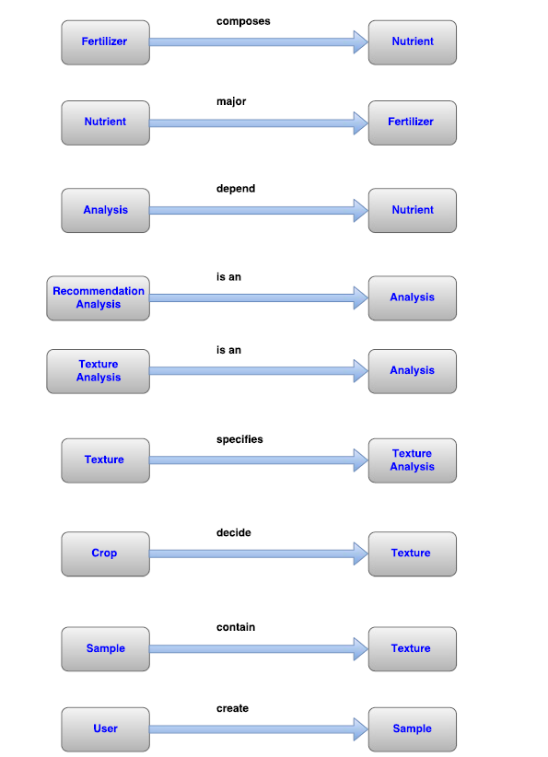

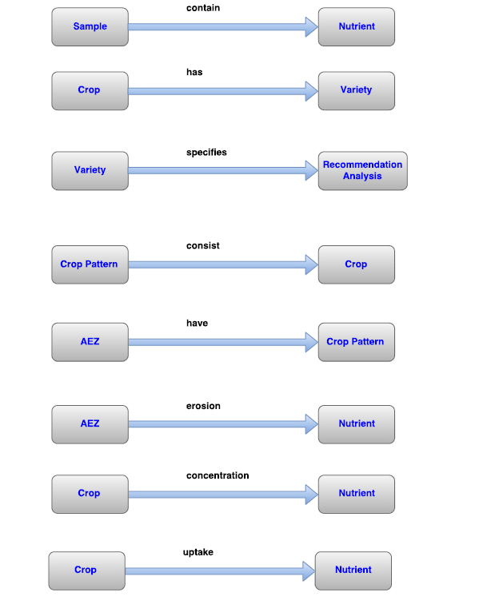

Figure 20: Relation between data objects

### 5.3 Entity Relationship Diagram

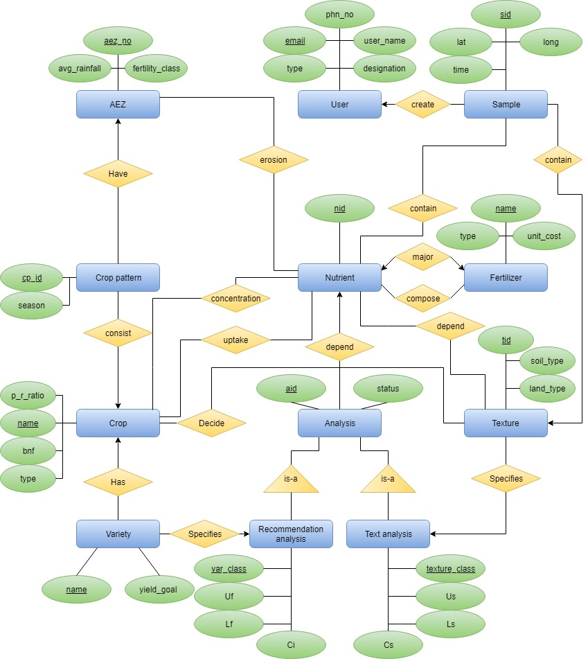

Figure 21: Entity Relationship Diagram

### 5.4 Schema Diagram

*Database schema has been added to the end of the document.

# Chapter 6

## Class Based Modeling

This chapter is intended to describe class based modeling of the Grocery Management System.

### 6.1 Class Based Modeling Concept

Class-based modeling represents the objects that the system will manipulate, the operations that will applied to the objects, relationships between the objects and the collaborations that occur between the classes that are defined.

### 6.2 General Classification

To identify the potential classes, nouns were selected from the solution space of the story. These were then characterized in seven general classifications. The seven general characteristics are as follows:

1. External entities

2. Things

3. Events

4. Roles

5. Organizational units

6. Places

7. Structures

Following are the specifications of the nouns according to the general classifications.

|  |  |  |
| --- | --- | --- |
| No. | Noun | GC |
|  | User | 4, 5, 7 |
|  | Email address |  |
|  | Phone number |  |
|  | Password |  |
|  | Name |  |
|  | Job title |  |
|  | Type |  |
|  | Field worker | 4, 5, 7 |
|  | Expert | 4, 5, 7 |
|  | Admin | 4, 5, 7 |
|  | System | 2, 5 |
|  | Fertilizer | 2, 5, 7 |
|  | Nutrient balance sheet |  |
|  | Soil sampling | 3, 7 |
|  | Crop | 2, 5, 7 |
|  | Nutrient | 2, 5, 7 |
|  | Crop name |  |
|  | Variety |  |
|  | Nutrient amount |  |
|  | Crop class |  |
|  | Soil texture |  |
|  | Texture class |  |
|  | Interpretation of the soil | 2, 6, 7 |
|  | Interpretation | 2, 6, 7 |
|  | Lower limit |  |
|  | Upper limit |  |
|  | Interval |  |
|  | Interpretation of nutrients for a specific crop class | 2, 6, 7 |
|  | Soil test value |  |
|  | Inorganic fertilizer | 2, 5, 7 |
|  | Organic fertilizer | 2, 5, 7 |
|  | Cost |  |
|  | Land type |  |
|  | AEZ | 4, 5, 7 |
|  | Residues removed |  |
|  | Nutrient input |  |
|  | Nutrient output |  |
|  | Fertility class |  |
|  | Average rainfall |  |
|  | BNF |  |
|  | Deposition |  |
|  | Sedimentation |  |
|  | Irrigation |  |
|  | Nitrogen-addition |  |
|  | Nitrogen-uptake |  |
|  | Crop produce |  |
|  | Leaching |  |
|  | Denitrification |  |
|  | Volatilization |  |
|  | Soil erosion |  |
|  | Nutrient concentration |  |
|  | Yield |  |
|  | Produce-residue ratio |  |
|  | Sample id |  |
|  | Location |  |
|  | Time |  |
|  | Latitude |  |
|  | Longitude |  |
|  | Ph |  |
|  | Crop type |  |
|  | Aez no |  |
|  | Database | 1, 6 |
|  | Crop Pattern |  |

Table 3: General Classifications of nouns

### 6.3 Selection Criteria

The potential classes were then selected as classes by six Selection Criteria. A potential class becomes a class when it fulfills all six characteristics.

1. Retained Information

2. Needed Services

3. Multiple Attributes

4. Common attributes

5. Common operations

6. Essential requirements

|  |  |  |
| --- | --- | --- |
| No. | Noun | GC |
|  | User | 1, 2, 3, 4, 5 |
|  | Field worker | 1, 2, 3, 4, 5 |
|  | Expert | 1, 2, 3, 4, 5 |
|  | Admin | 1, 2, 3, 4, 5 |
|  | System | 6 |
|  | Fertilizer | 1, 3, 4, 5 |
|  | Soil sampling | 1, 3, 4, 5 |
|  | Crop | 1, 3, 4, 5 |
|  | Nutrient | 1, 3, 4, 5 |
|  | Interpretation of the soil | 1, 3, 4, 5 |
|  | Interpretation | 1, 3, 4, 5 |
|  | Interpretation of nutrients for a specific crop class | 1, 3, 4, 5 |
|  | Inorganic fertilizer | 1, 3, 4, 5 |
|  | Organic fertilizer | 1, 3, 4, 5 |
|  | AEZ | 1, 3, 4, 5 |
|  | Database | 6 |

Table 4: Selection Criteria for potential classes

### 6.4 Associate Noun and Verb Identification

|  |  |  |  |
| --- | --- | --- | --- |
| No | Potential Class | Noun | Verb |
|  | User | Name, job title, password, email, phone number | Validate, verify |
|  | Expert | Name, job title, password, email, phone number | Validate, verify, upload, create sample, view, update |
|  | Admin | Name, job title, password, email, phone number | Validate, verify, upload, approve, view, update |
|  | Field Worker | Name, job title, password, email, phone number | Validate, verify, upload, create sample |
|  | Crop | Name, variety, class | Get class, calculate seasonal balance, get interpretation, calculate bnf, calculate sedimentation, calculate irrigation, calculate total input, calculate harvested product, calculate leeching, calculate gaseous, calculate residues, calculate total output |
|  | Fertilizer | Name, quantity, unit cost | Calculate fertilizer, get nutrient ratio |
|  | Organic Fertilizer | Name, quantity, unit cost | Calculate fertilizer, get nutrient ratio |
|  | Inorganic Fertilizer | Name, quantity, unit cost | Calculate fertilizer, get nutrient ratio |
|  | AEZ | Aez no, average rainfall, fertility class, season, land type | Calculate deposition, calculate erosion, Calculate balance graph |
|  | Sample | Id, location, longitude, latitude, time, texture, ph | Get location, calculate Ph |
|  | Nutrient | Name, quantity | Calculate nutrient, get composition |
|  | Interpretation | Status, lower limit, higher limit, range |  |
|  | Interpretation of nutrients for a specific crop |  | Get recommendation |
|  | Interpretation of soil |  | Get recommendation |
|  | Database |  |  |
|  | System |  |  |

Table 5: Associated nouns and verbs of the potential class

### 6.5 Attribute Selection

|  |  |  |
| --- | --- | --- |
| No | Class | Attributes |
|  | User | name  email  phone  password  title |
|  | Admin | name  email  phone  password  title |
|  | Expert | name  email  phone  password  title |
|  | Field Worker | name  email  phone  password  title |
|  | Crop | name  variety  nutrient  recommendator  harvestedProduct  leeching  gaseous  residues  bnf  manure  sedimentation  irrigation |
|  | Fertilizer | name  commercialName  unitCost  quantity |
|  | OrganicFertilizer | name  unitCost  quantity |
|  | InorganicFertilizer | name  commercialName  unitCost  quantity |
|  | AEZ | aezNo  season  landType  avgRainFall  crop  erosion  deposition |
|  | Sample | id  location  time  nutrient  texture  ph |
|  | Nutrient | name  quantity  requiredNutrient  cropName |
|  | Interpretation | Status, lower limit, higher limit, range |
|  | Interpretation of nutrients for a specific crop |  |
|  | Interpretation of soil |  |
|  | Database |  |
|  | System |  |

Table 6: Attribute selection of classes

### 6.6 Methods Identification

|  |  |  |
| --- | --- | --- |
| No | Class | Methods |
|  | User | validate()  verify() |
|  | Admin | approve()  createSample()  validate()  verify() |
|  | Expert | createSample()  validate()  verify() |
|  | Field Worker | createSample()  validate()  verify() |
|  | Crop | getClass()  getRecommendation()  calculateHarvestedProduct()  calculateLeeching()  calculateGaseous()  calculateResidues()  calculateBnf()  calculateManure()  calculateSedimentation()  calculateIrrigation() |
|  | Fertilizer | calculateFertilizer()  getNutrientRatio()  calculateTotalCost() |
|  | OrganicFertilizer | calculateFertilizer()  getNutrientRatio() |
|  | InorganicFertilizer | calculateFertilizer()  getNutrientRatio()  calculateTotalCost() |
|  | AEZ | getAvgRainFall()  calculateErosion()  calculateDeposition()  calculateBalance()  showBalanceGraph() |
|  | Sample | generateLocation()  calculatePH() |
|  | Nutrient | calculateNutrient()  getComposition()  calculateTotalBalance() |
|  | Interpretation |  |
|  | Interpretation of nutrients for a specific crop | getFertilizerRecommendation()  getNutrientRecommendation() |
|  | Interpretation of soil | getNutrientRecommendation() |
|  | Database |  |
|  | System |  |

Table 7: Method Selection of classes

### 6.7 Finalizing Classes

* User, Admin, Expert and Field Worker classes are merged into User as these share same attributes and methods.
* Crop class has become big. So, it some of its attributes and methods has been transferred to two new classes: Input and Output. Input class refers to all the nutrients that get absorbed by the crop and Output class refers to all the nutrients released by the crop.
* Interpretation, Interpretation for soil and Interpretation of nutrients for specific crops has been merged and a new class Recommendator has been created. Also, Interpretation class will be used as a data class which will have lower limit, upper limit, interval and status as its attributes.
* Rest of the classes have been created.

### 6.8 Class Relation Collaboration

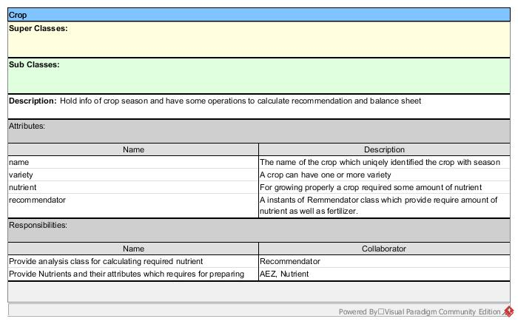

Figure 22: CRC Crop

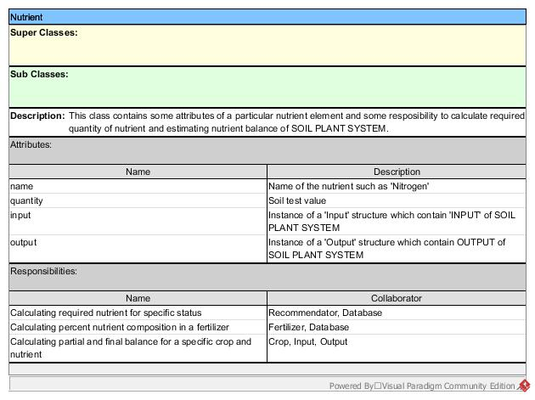

Figure 23: CRC Nutrient

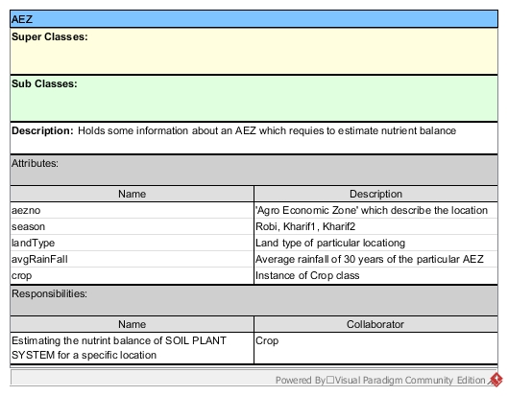

Figure 24: CRC AEZ

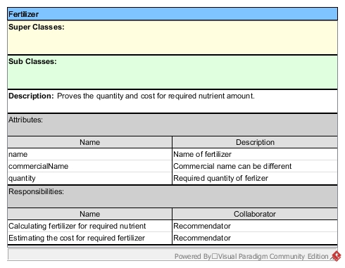

Figure 25: CRC Fertilizer

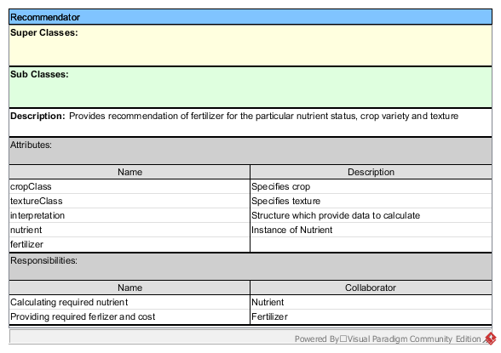

Figure 26: CRC Recommendator

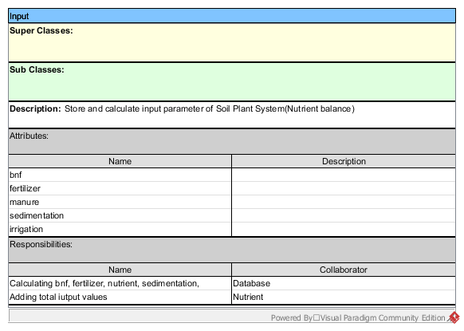

Figure 27: CRC Input

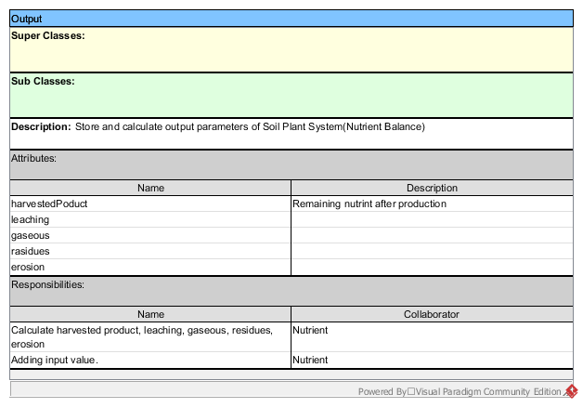

Figure 28: CRC Output

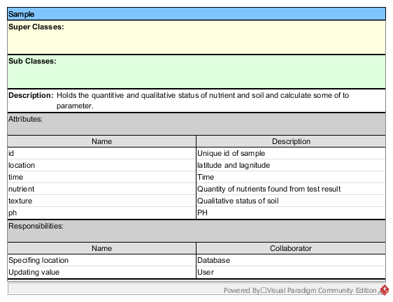

Figure 29: CRC Sample

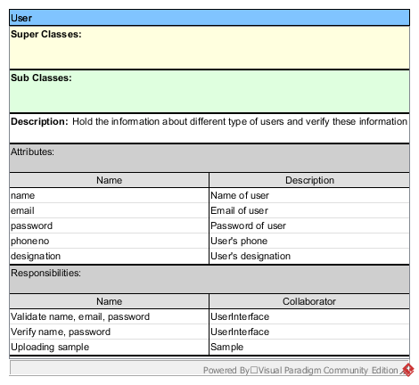

Figure 30: CRC User

### 6.9 Class Diagram

*Class diagram has been added to the end of the document separately.

# Chapter 7

## Behavioral Modeling

### 7.1 State Transition Diagram

State diagram represents active states for each class the events (triggers). For this we identified all the events, their initiators and collaborators.

#### Identifying Events

|  |  |  |  |
| --- | --- | --- | --- |
| No | Event | Initiator | Collaborator |
|  | Verify | User: verify() | Database: query() |
|  | Approve | User: approve() | Database: insert() |
|  | Upload Soil Sample | User: upload() | Database: insert() |
|  | Validate | User: validate() |  |
|  | Identify location | Sample: generateLocation() |  |
|  | Calculate pH | Sample: calculatePH() |  |
|  | Update value | Sample: updateValue | Database: update() |
|  | Show balance graph | AEZ: calulateBalance(), showBalanceGraph() | Crop: calculateSeasonalBalance() |
|  | Get crop class | Crop: getCropClass() | Database: query() |
|  | Calculate Recommendation | Crop: calculateRecommendation() | Recommendator: Recommendator() |
|  | Set interpretation | Recommendation: setInterpretation() | Database: query() |
|  | Get Nutrient Recommendation | Recommendation:  getNutrientRecommendation() | Nutrient: calculateNutrient() |
|  | Get fertilizer recommendation | Recommendation: getFertilizerRecommendation() | Fertilizer: calculateFertilizer() |
|  | Calculate Fertilizer | Fertilizer: calculateFertilizer() | Database: query() |
|  | Calculate Cost | Fertilizer: calculateTotalCost() | Database: query() |
|  | Get nutrient ratio | Fertilizer: getNutrientRatio() | Nutrient: getComposition() |
|  | Calculate Nutrient | Nutrient: calculateNutrient() | Database: query() |
|  | Calculate composition | Nutrient: getComposition() | Database: query() |
|  | Calculate Seasonal Balance | Crop: calculateSeasonalBalance() | Nutrient: calculateTotalBalance() |
|  | Calculate total balance | Nutrient: calculateTotalBalance() | Input: calculateTotal()  Output: calculateTotal() |
|  | Calculate Total Nutrient Input | Input: calculateTotal() calculateBnf() calculateSedimentation() calculateIrrigation() | Database: query() |
|  | Calculate Total Nutrient Output | Ouput: calculateTotal() calculateHP() calculateLeeching() calculateGaseous() calculateResidues() calculateErosion() | Database: query() |

Table 8: Event Identification

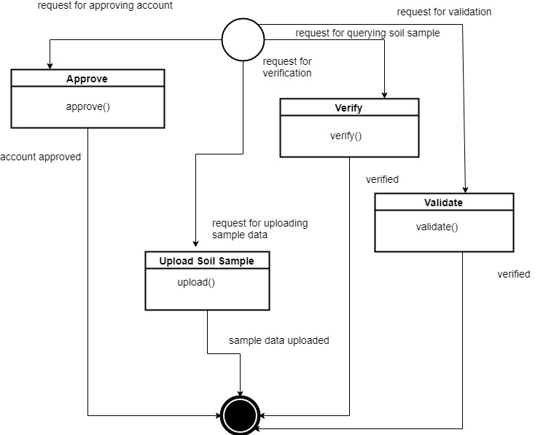

Figure 31: State Transition User

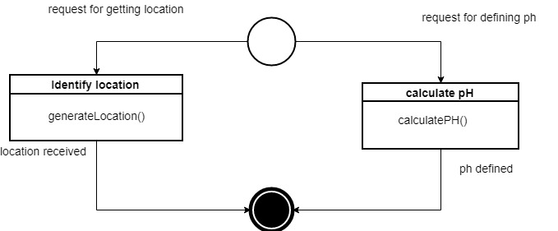

Figure 32: State Transition Sample

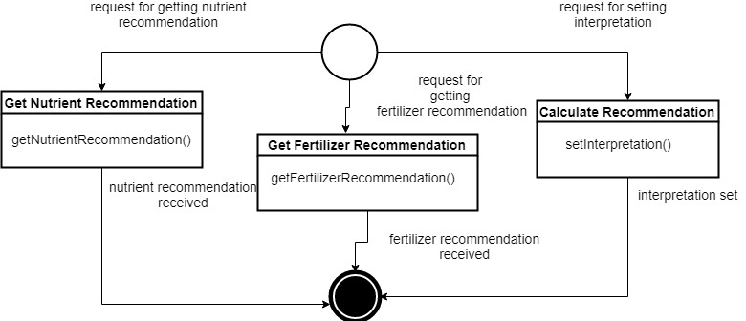

Figure 33: State Transition Recommendation

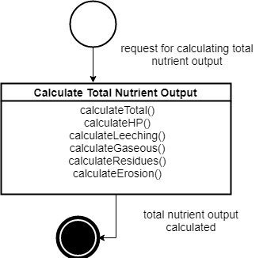

Figure 34: State Transition Output

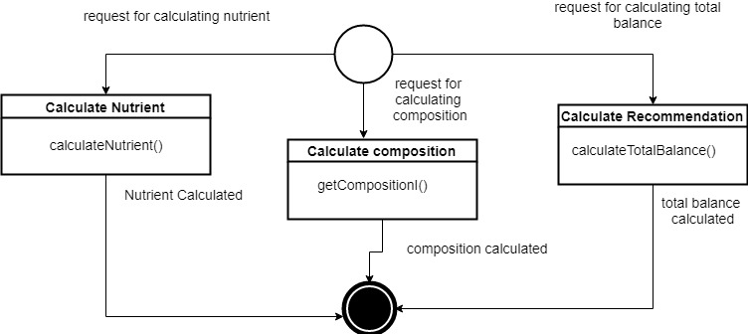

Figure 35: State Transition Nutrient

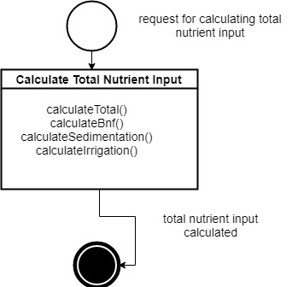

Figure 36: State Transition Input

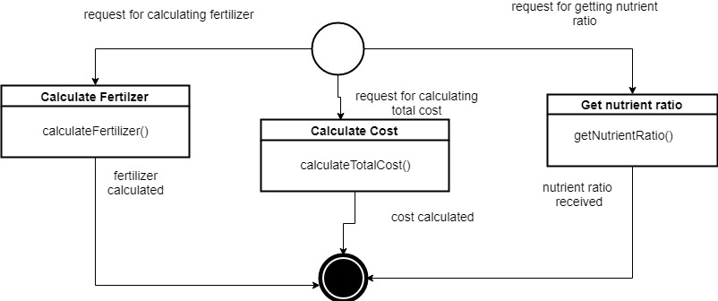

Figure 37: State Transition Fertilizer

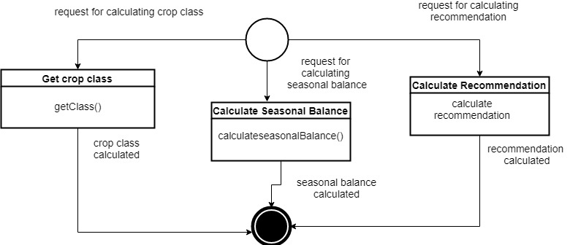

Figure 38: State Transition Crop

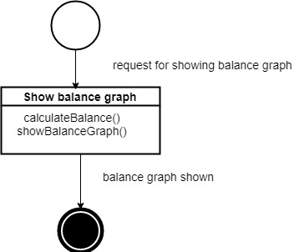

Figure 39: State Transition AEZ

### 7.2 Sequence Diagram

*Sequence has been added to the end of the document.

# Chapter 8

## Data Flow Diagram

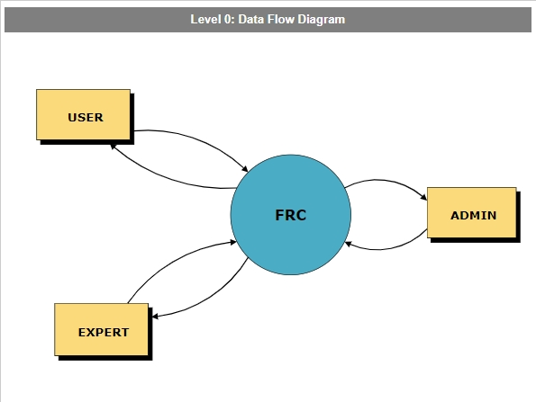

Figure 40: Data Flow Diagram Level 0

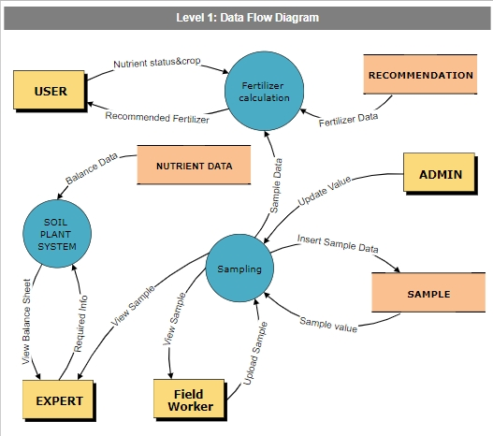

Figure 41: Data Flow Diagram Level 1

# Chapter 9

## Conclusion

From this SRS report on Fertilizer Recommendation Calculation, the readers will get a clear and easy view of the overall system of management system of the regular grocery shops. This SRS document can be used effectively to maintain the software development cycle. It will be very easy to conduct the whole project using SRS. Hopefully, this document can also help the junior BSSE students. We tried best to remove all dependencies and make an effective and fully designed SRS.